RE Mech App - Vehicle Check-In [POC]


FF Mechanic App

SOP

*CONFIDENTIAL*
The details contained in this document represents proprietary, confidential information pertaining to products, technologies, and processes from Flying Flea. All information in this proposal is to be treated in confidence and no duplication, copyright or patent application is allowed for any of the details from this document/part/product.

OBJECTIVE
This document provides a clear, step-by-step guide for users of the FF Mech App. It is designed to help users understand the functionality and easily navigate the Application. By following this guide, users can explore all sections, make full use of the available tools, and troubleshoot common issues, ensuring a smooth and confident experience when using the Mech app.

S.No | Version No | Date | Change description | Author | Reviewed | Approved
1 | 1.0 | 30-Mar-2026 | FF Mechanic App | Kaaviya Lakshmi | Arun Prasath V | Arun Prasath V

I. App Installation
Install the Flying Flea Mechanic App from Playstore / Appstore
II. Pre-Diagnostics Procedure
- Turn on the vehicle and connect it to the FF Mechanic app.
- Go to the 'Disconnect' screen and select 'View Admin PIN'.
- Enter the one-time password (OTP) sent to your registered mobile number or email to verify your identity to view the Admin PIN.
- Use the Admin PIN displayed in the app to unlock the vehicle.
- Once you have unlocked the vehicle, set it to "Standard" mode using the bike's display screen (the Cluster). To do this:
Navigate to Settings > Vehicle Modes > Standard mode.
- Once the Mechanic App is connected and the above steps are followed, technicians can continue diagnosing the vehicle
III. Post Diagnostics Procedure
- After completing the diagnostics activities with FF Mechanic App, it is MANDATORY to DISCONNECT the vehicle from the App.
- After disconnecting the app, verify the timestamp in Remote diagnostics to ensure the communication with Cloud.
- If there are time differences / Lag in timestamp, Reconnect and disconnect the vehicle with the FF Mechanic app, then verify the timestamp in Remote diagnostics to ensure the communication with Cloud again before delivering the vehicle to customer.
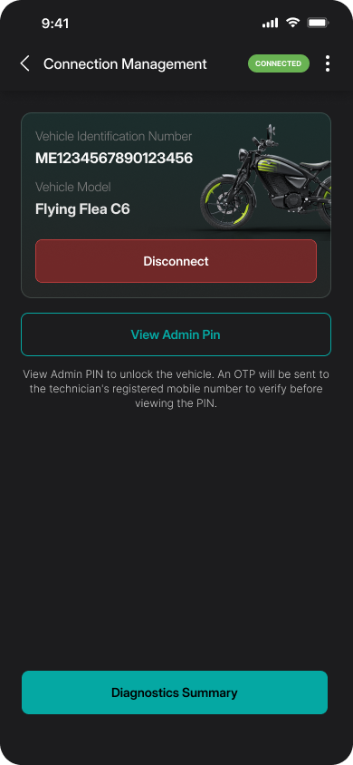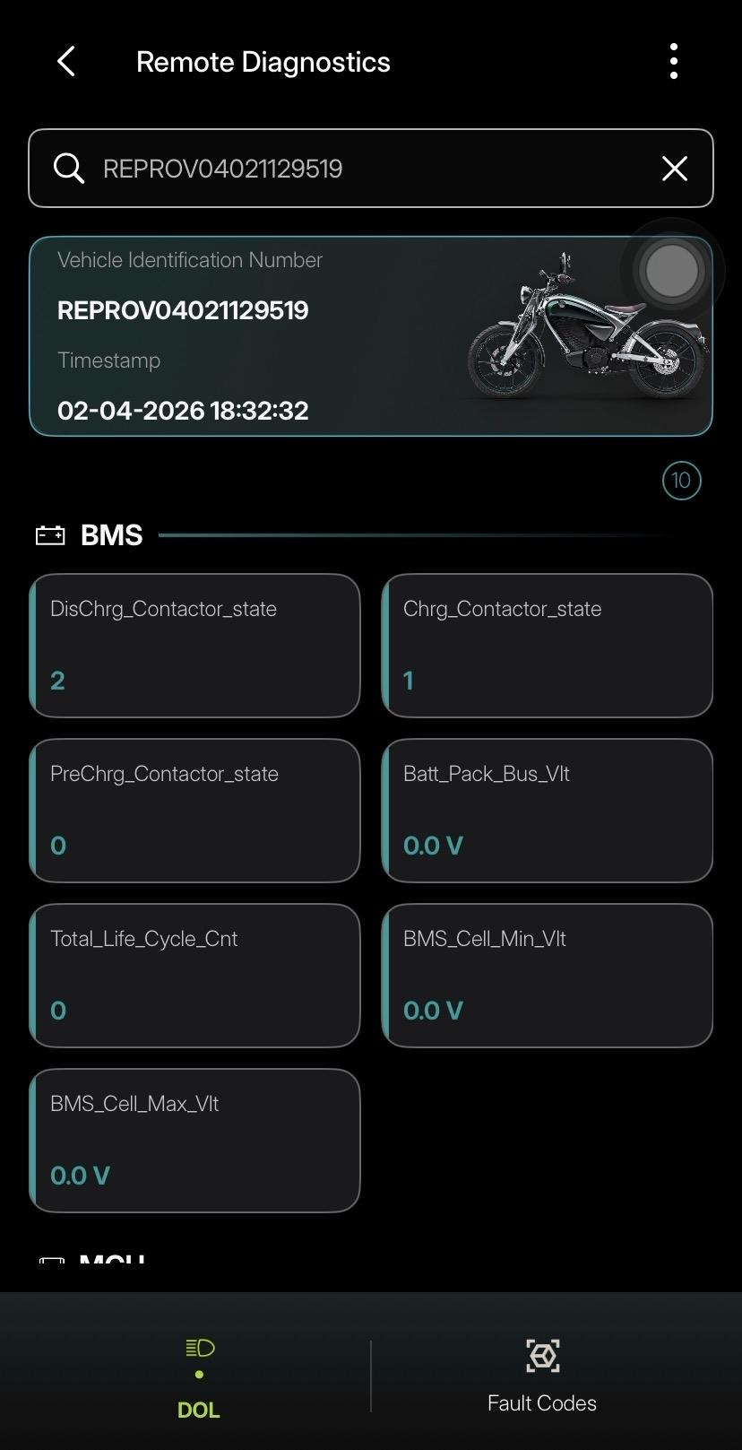

IV. Login and Security
- Login with Mobile Number and Password
After clicking the FF Mech application, the Log-In screen will appear, and the user shall enter their registered credentials to proceed further.
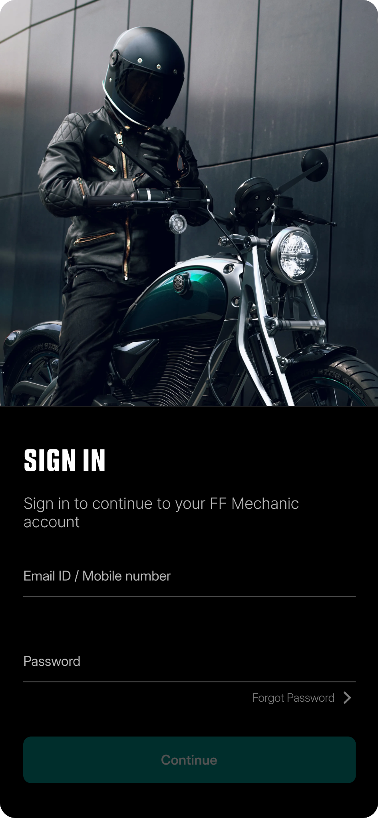
- Set PIN
After entering their credentials, the user will be directed to the Set New PIN page where they set a 4-digit unique PIN to access the app.
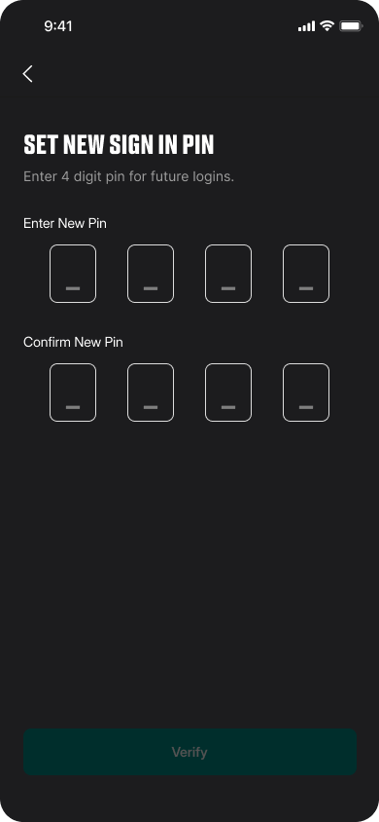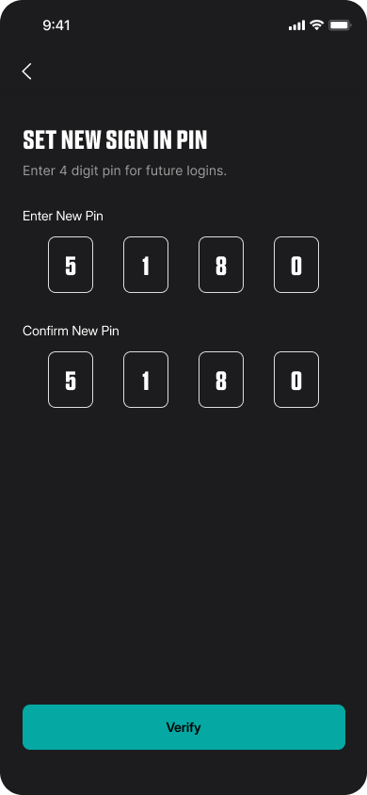
- Successful Log-In Note
After setting the new PIN, the user will see the successful PIN setup screen.
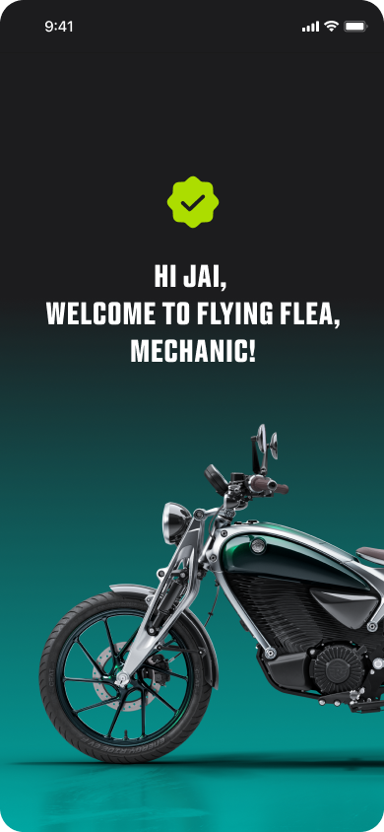
- Login with PIN
After successfully setting the PIN, the user will be prompted to enter the new PIN to log in to their account.
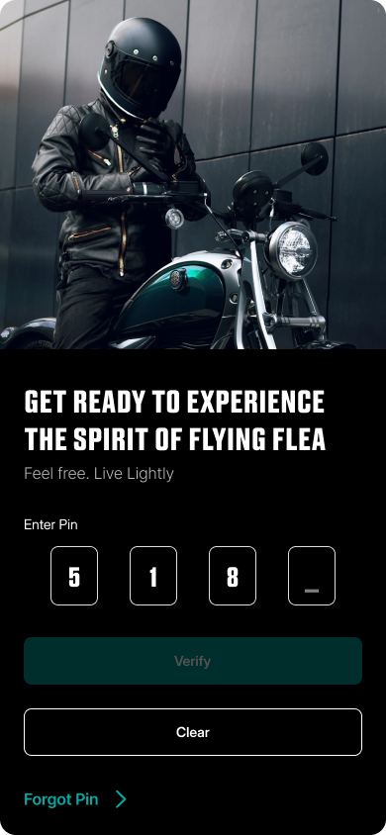
- Forget & Change Password
The user can
  - Enter their Phone number to change the Password.
  - Enter their current password to change the password.
  - Receive a "Password change Successful" notification.
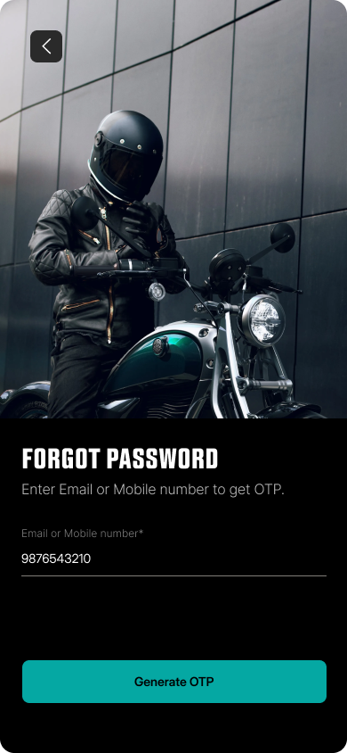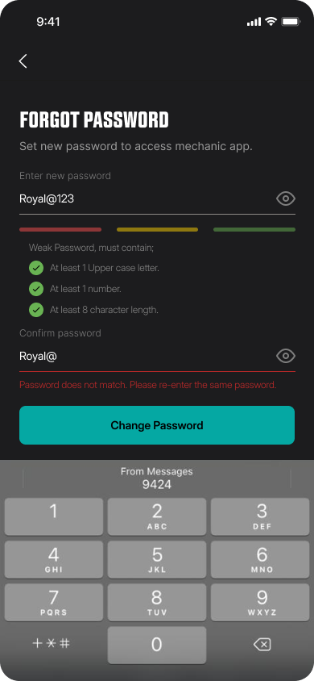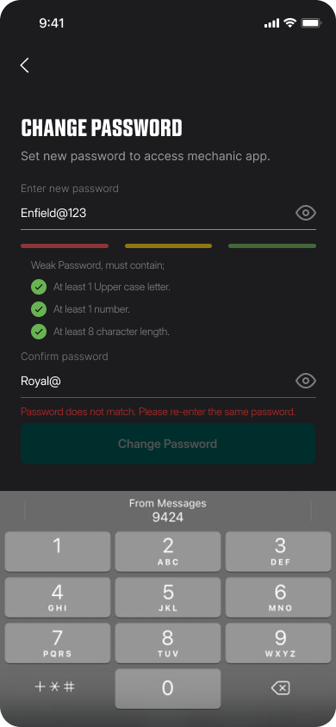
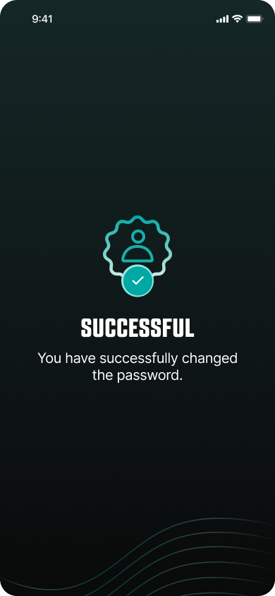
III. Homescreen and Core Features
- Homescreen
The Homescreen provides access to the following main features:
  - Remote Diagnostics: To get DOL-Live parameters and Fault codes remotely by fetching data from the cloud.
  - Customer onboarding: To complete the customer onboarding process including Diagnostics and adding ownership details.
  - Service Manual: To download and View Service Manual PDF.
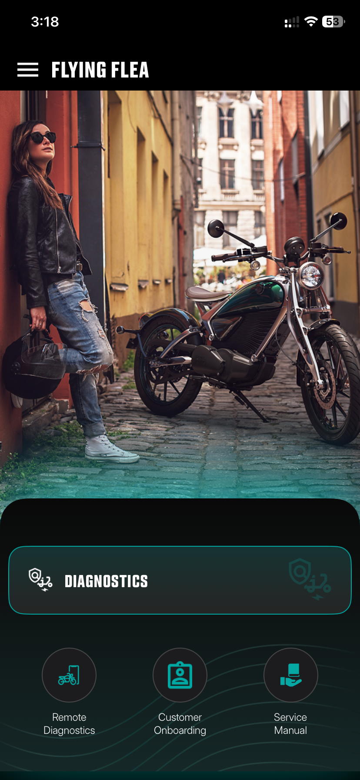
- Diagnostics - Connection Management
  - To perform Diagnostics in the vehicle, FF Mechanic app to be connected with the vehicle via wifi
  - Enter / Scan Text / Scan QR code of the Vehicle Identification Number (VIN).
  - Select Connect.
  - The status will show "Connection Successful".
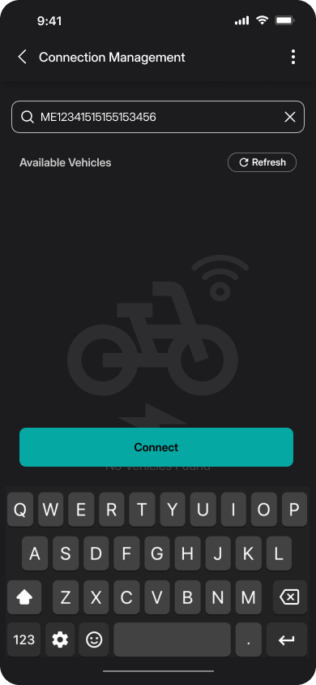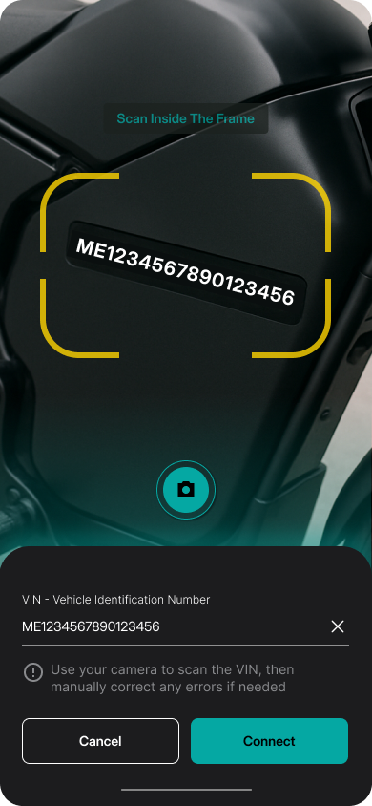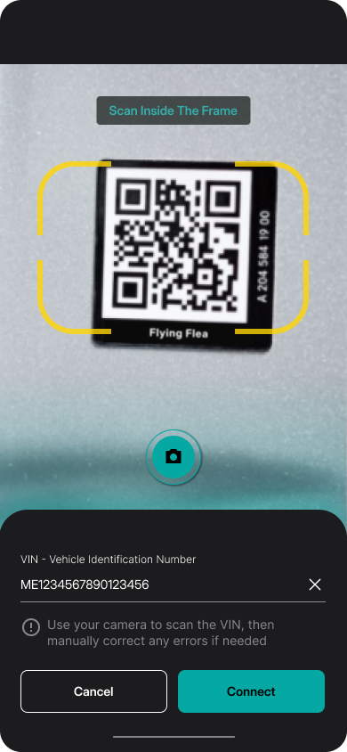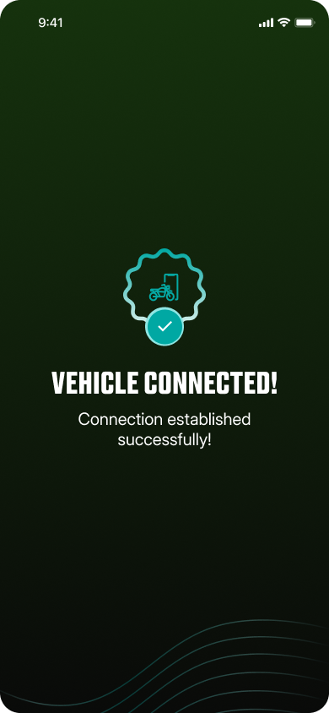

- To Disconnect the vehicle, select the “Disconnect” button in this screen.
Note: After completing the diagnostics activities with FF Mechanic App, it is MANDATORY to disconnect the vehicle from the App.


- After disconnecting, please check the timestamp for last communication time with the cloud.
- If there are any differences in timestamp, Turn on the service mode in the vehicle then reconnect and disconnect the app to establish communication with the cloud.

- Diagnostics Summary & Vehicle Info
  - Diagnostics Summary: Used to view the summary of ECU health, view Live parameters and Fault codes, and perform OTA update.
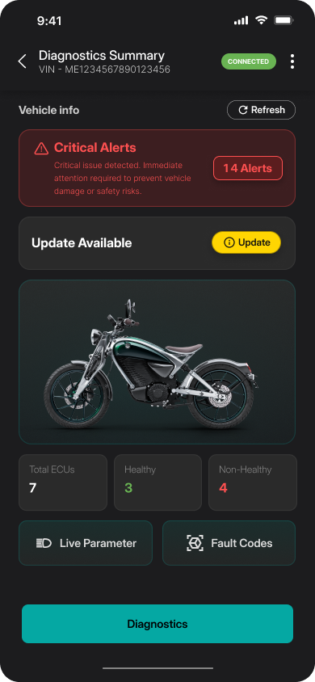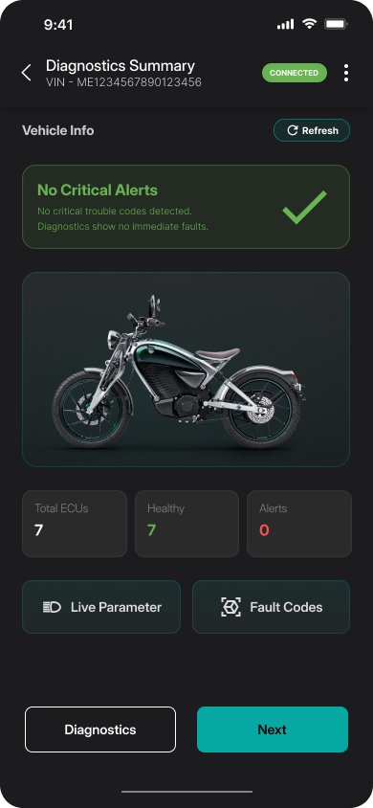

  - Vehicle Info: By Selecting the Diagnostics button in Diagnostics summary screen, Users can view ECU wise information and select the ECU to perform diagnostics based on the ECU.
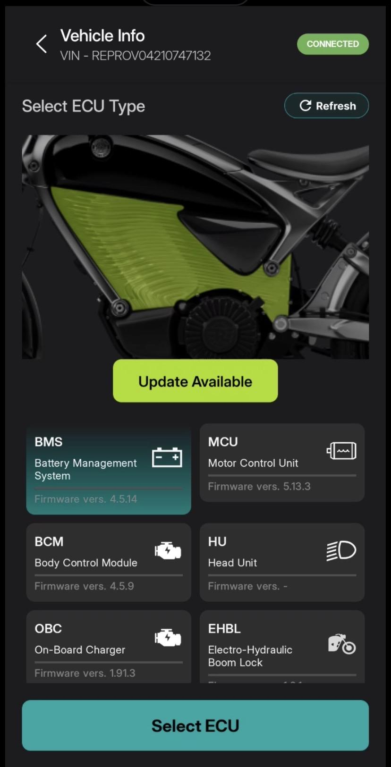

  - Diagnostics - Live Parameters, DTC & Fault codes:
    - DOL - Live parameters: To view ECU wise Live parameter values.
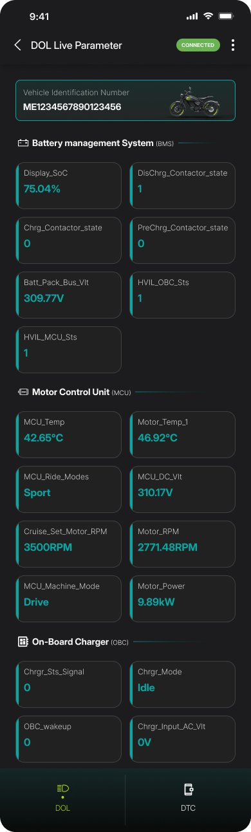
    - DTC - To view the DTC (Diagnostics Trouble codes) currently available in vehicle in active and pending state
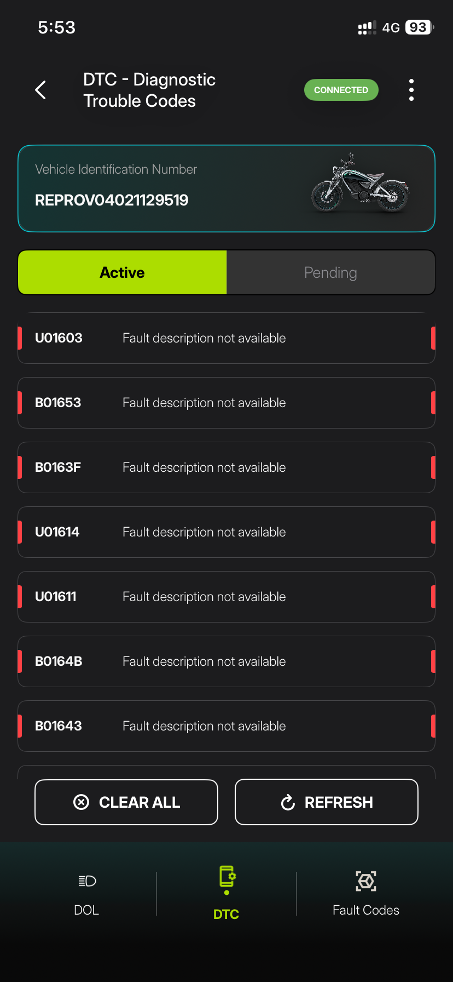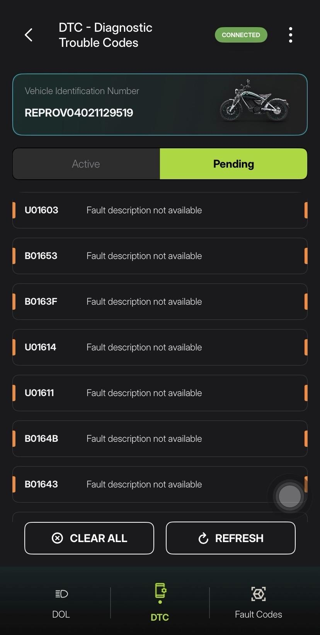
    - Fault codes: To view Fault code values.
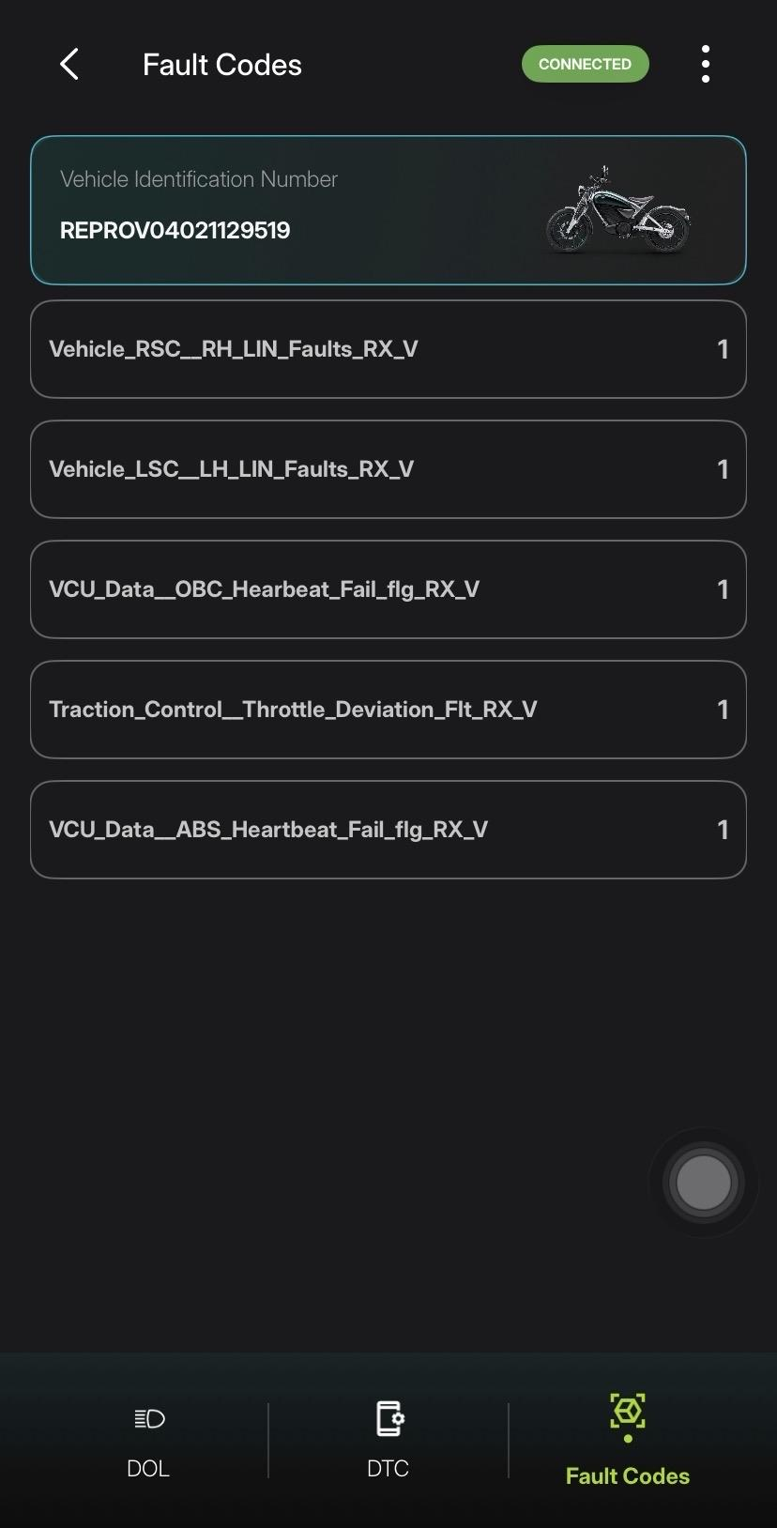
- Customer Onboarding - Domestic
  - Enter / Scan VIN.
  - Check for Customer Onboarding checklist status.
  - Perform Diagnostics; Diagnostics completed.
  - Verify Customer info. in ownership details.
  - Select Next if data is right.
  - A trigger is sent to submit customer info., Vehicle activation, and Owner communication; Customer onboarding checklist completed.
  - To verify the status again, enter the VIN and check the status.
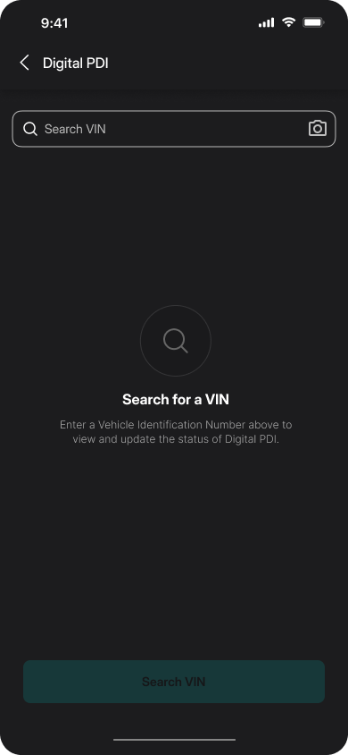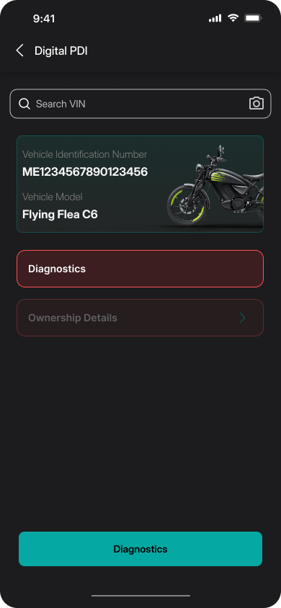
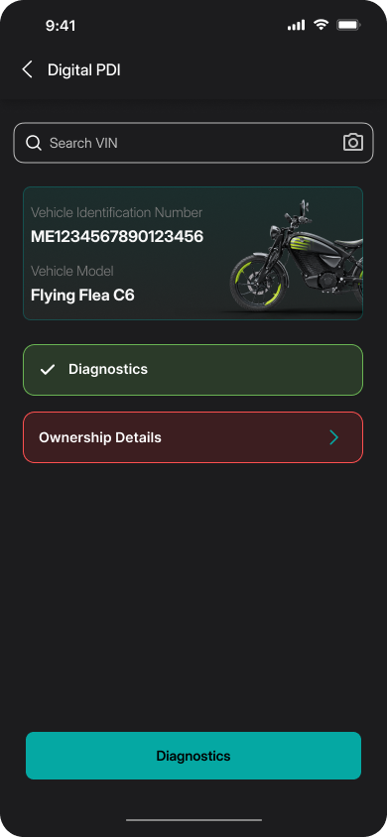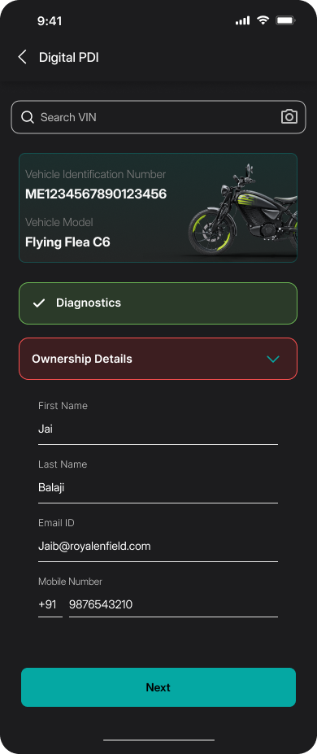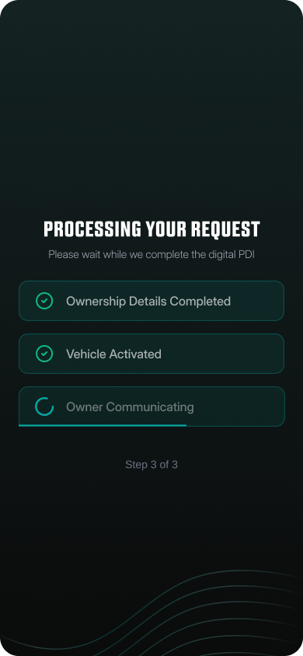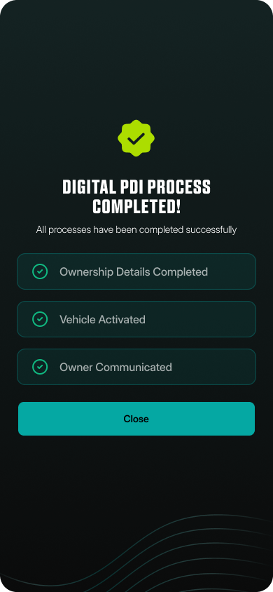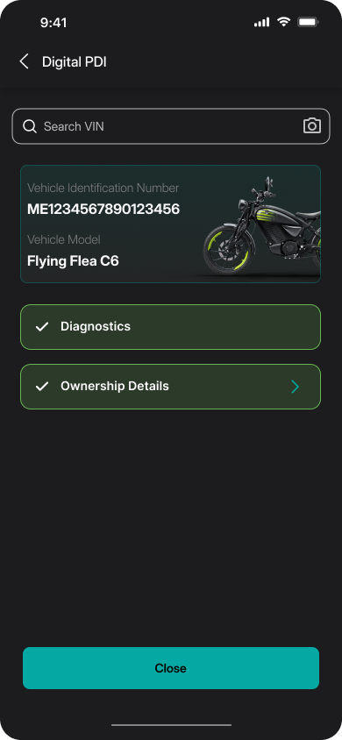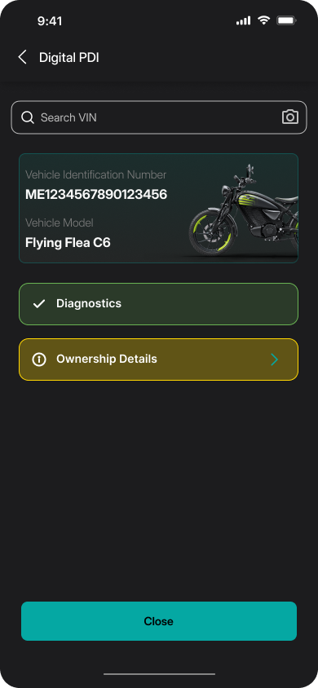

- Remote Diagnostics
  - Select Remote Diagnostics in the Homescreen / side Menu.
  - Enter VIN.
  - View DOL - Live parameters.
  - View Fault codes.
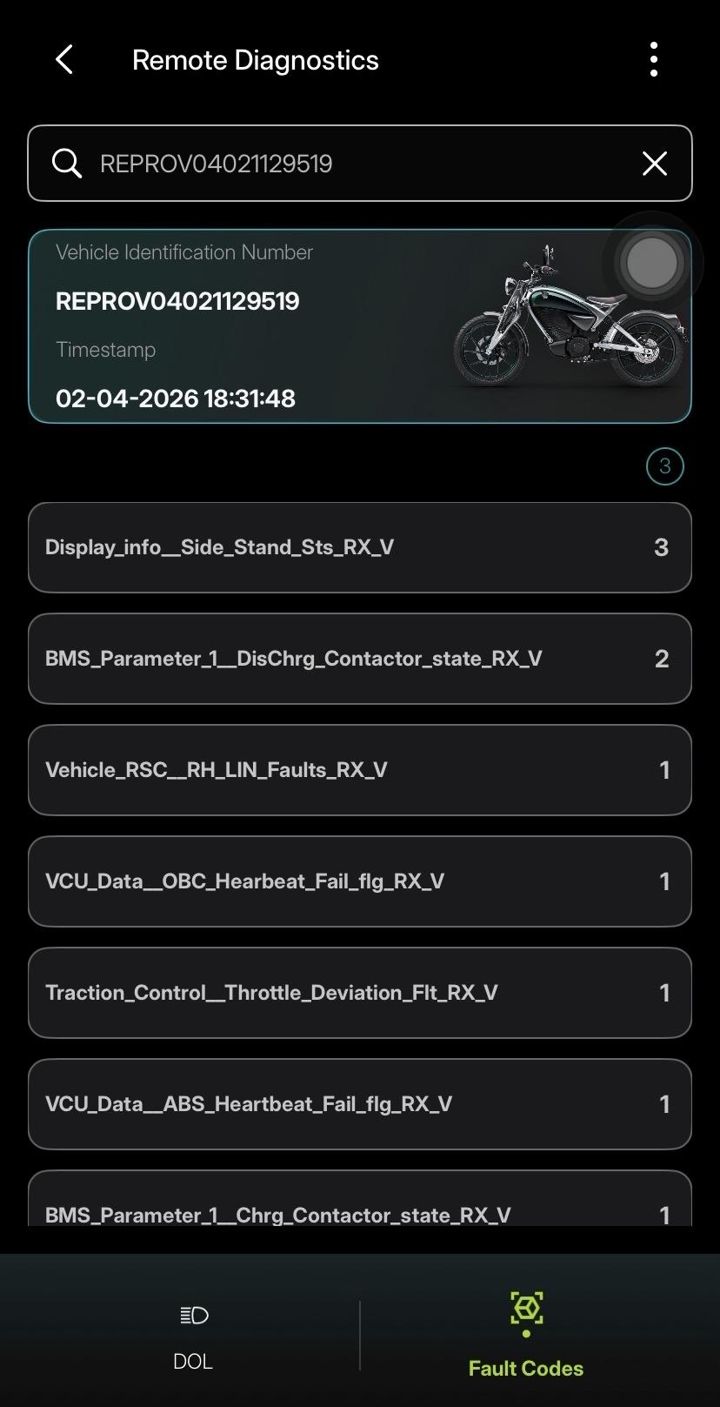

- OTA (Over-The-Air) Update
Vehicle Pre-conditions to perform OTA:
- SOC ~ 70%
- Vehicle should be on Park Mode
- Bike should be on center stand
- Data Pack recharged
- Cloud provision
- Charging cable should not be connected
OTA with FF Mechanic App:
  - Download OTA file in the app by selecting download button.
  - After download select the install in the pop up to proceed with installation.
  - Install OTA file to the vehicle by selecting install button. Installation would take some time to complete.
  - User will get the status "OTA update Successful" if OTA installation is successful.
